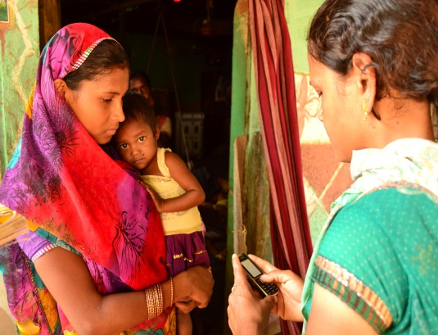

Case Study: Kenya National Hospital Insurance Fund (NHIF)
Premium Collection for the Informal Sector

Updated: June 9, 2014
Program overview
The Kenya National Hospital Insurance Fund (NHIF) is the oldest government insurance scheme in Africa. As the primary provider of health insurance in Kenya its mandate is to provide access to quality and affordable health care for all Kenyans. NHIF membership is compulsory for all salaried employees. Premium contributions are calculated on a graduated scale based on income, and deducted automatically through payroll. For self-employed and other informal sector workers, membership is contributory (voluntary) and available at a fixed premium rate of 160 Kenya Shillings (KES) per month. Overall membership enrollment for formal and informal sector populations has reached 4.5 million people (11% of the Kenyan population). While coverage is high for the formal sector (98%), coverage of the informal sector which accounts for over 80% of Kenya’s workforce has proven to be more challenging, and remains low at 16% of the informal sector population.

Mobile Money
To facilitate timely remittance of member contributions and maintenance of up-to-date payment information for individual accounts, NHIF has partnered with Safaricom Limited, a leading telecommunications company in Kenya, to provide a flexible and convenient platform for remittance of monthly insurance premium contributions from informal sector populations. NHIF no longer transacts in cash for premium collections and has additionally partnered with banks to enable direct cash and check deposits from members. A key goal of these partnerships is to improve access to and utilization of the NHIF services.

The use of the highly successful and innovative M-Pesa money transfer platform has enabled NHIF to extend health services to informal sector workers who are not captured in formal payroll systems and whose incomes are often less regular or predictable. The option to make monthly insurance contributions using M-Pesa has helped to minimize travel to NHIF offices and time spent in long lines away from productive livelihood activities. Additionally, by allowing workers to make incremental contributions to their monthly premium, the M-Pesa platform has helped to reduce the frequency of NHIF’s penalty charge – 5 times the monthly contribution amount for those who default in remitting contributions. The steep penalty fee has been a major deterrent to re-enrollment for defaulted members as well as attraction of new members.
Type of program: collection of health insurance premium payments
Date launched: 2010
Scale: National-level
Size: Close to 100,000 NHIF members use M-pesa for paying monthly insurance premiums
Country: Kenya
Area of the country: country-wide
Funding: NHIF
Key partners: Safaricom
Since launch in 2010, the number of NHIF members using M-Pesa to make monthly premium contributions has grown nearly ten-fold from 10,000 to close to 100,0000 in 2014. To use the M-Pesa payment platform, members must already be registered users of M-Pesa and possess a National ID, a requirement for making M-Pesa payments. Revenue collection for NHIF grew from 1M KES per month at the end of the 2011, to an average of 35 M KES per month in 2013.

Challenges
- Integration of systems. Initially, there were challenges and delays in integrating the M-Pesa payment platform with the NHIF payment and information technology system. Beneficiaries would often arrive at health facilities to learn that they could not access services because contributions were not being reflected in membership accounts in a timely manner. This has now been corrected and is recognized by the NHIF as an important consideration to take into account when introducing new payment platforms.
- Identifying bottlenecks. In its first iteration, NHIF’s M-Pesa payment system was not able to detect information that might have been entered erroneously. All payments were processed regardless of whether the member account information was correct or not. It was a long and tedious process for NHIF staff to trace these errors which often were the result of a mis-keyed number, and correctly assign payment to the right individual. The delays affected members who could not access services until their accounts were credited with the correct payment amounts.

Lessons learned
How M-Pesa Payment Collection Works:
- Select Pay Bill option
- Enter NHIF Business Number
Type 200222
- Enter a/c no
Type in contributor’s National Identity Number
- Enter amount
Type in the amount you wish to contribute
- Enter Pin
Type M-pesa PIN
- Confirm details are correct and hit OK

You will receive two confirmation SMS’s from M-Pesa and NHIF immediately

- Fewer cashiers are required to handle M-Pesa payments. This has helped to reduce administrative and paper work burdens.
- The M-Pesa payment system has made it possible for individuals to submit payments on behalf of others with limited or no income, including extended family members, orphans, elderly persons and persons with disability.

Looking forward
NHIF has set an ambitious target of enrolling a total of 10M Kenyans with 33% or approximately 3M comprising the informal sector, by the end of 2014. A media campaign focused on creating awareness of the health coverage plan for the informal sector and the flexible M-Pesa payment option is underway. This includes print, media and radio ads in vernacular language to reach populations in rural areas. NHIF is also exploring a bulk SMS offering with Safaricom to send reminders to members about the status of payments, coverage and important NHIF contact information.
Finally, in the near future NHIF plans to introduce scratch cards in fixed increments as another convenient and flexible option for remittance of monthly premium contributions from informal sector populations. For this offering, NHIF intends to contract with agents who have access to remote, internal and marginalized areas of the country where branch offices may not exist. These agents would have the ability both to register new beneficiaries and issue NHIF membership cards.

Sources
- Interview with, Juliet Maara, Senior Programme Officer, NHIF March 19, 2014

.

